The Influence of Music
Age Group: appropriate for middle and high school (may take 2-3 sessions if you do the art activity)
Purpose of lesson: To explore how music has been used throughout time from the beginning of creation to convey emotion and/or entertainment. Music ties to our emotions, to feel praises, pomp of a parade, sound of war, call to worship, sounds of happiness and sadness.
Key question: When, why and how was music used in the scriptures? How does this compare to your music choices?
Scripture references:
(Notes from one of Adam Porter’s sermons)
Suggestion for reading: Have students break up into small groups to look up a section of scriptures and report back to the group what they read.
First use of instruments
Genesis 4:21, the harp and organ mentioned.
1st Samuel 16:15-23 soothes Saul
1st Samuel 18: 6,7; Israel triumphs
1st Chronicles 15: 16, 24-29; the ark comes to Jerusalem
2nd Chronicles 29: 20-30; used in cleansing process for the temple
We find different attitudes in the use of music and song.
Ether 3: 10-11, Jaredites
1st Nephi 5: 182 Lehi’s sons
Daniel 3: 1-11 false worship forced
1st Nephi 1:7 Lehi witnesses the angles praising in heaven
Exodus 15:1-5 overcoming Pharoah
Revelations 15:2-3, singing a song of eternal victory
Ephesians 5:15-20, melody in your heart
Matthew 26:30, a hymn at the last supper
Moroni 6:9, in our meetings
To feel praise:
Mormon 3:27-29 ceaseless praise
Mosisah 9:66-67 praise forever
Alma 3:11-18 & 46, the song of redeeming love
Summary:
Thoughts to consider-
What does Jesus think of your music choices? Are they acceptable to the Lord? Do your choices promote or degrade your belief in Jesus Christ?
If we enjoy a tune, and we say we like the beat, are we listening to the lyrics? What do they express and are these favorite tunes a vehicle to inject a message (positive or negative)?
Activity: Create a wall plaque that promotes building your faith through music.
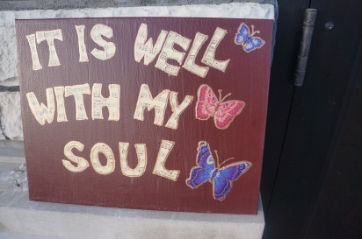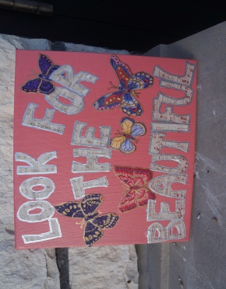
Materials needed: Artist canvas; 8 x 10, or 12 x 15, acrylic paint, Hodpodge decoupage, scrapbook paper of sheet music (or sheet music), fabric for embellishment, Sharpie marker (bronze, gold or silver), stencils, scissors, paintbrushes.
- Choose a hymn that you enjoy. I used “It is Well With My Soul” and “Look for the Beautiful”.
- Paint the canvas. Let it dry for a couple hours.
- Cut lettering out of scrapbook paper or sheet music using freestyle, stencils, Cricut machine, etc.
- Prepare decorative embellishment. I cut flowers and butterflies out of fabric.
- Place letters and decoration on canvas to practice where you want them to be, then remove and set to the side.
- Apply a coat of decoupage over the canvas.
- Immediately place letters and decoration on top of the wet decoupage.
- Apply another coat of decoupage over the lettering and decoration.
- Let dry completely (couple of hours)
- Outline the lettering and if you wish the decoration with a marker.

